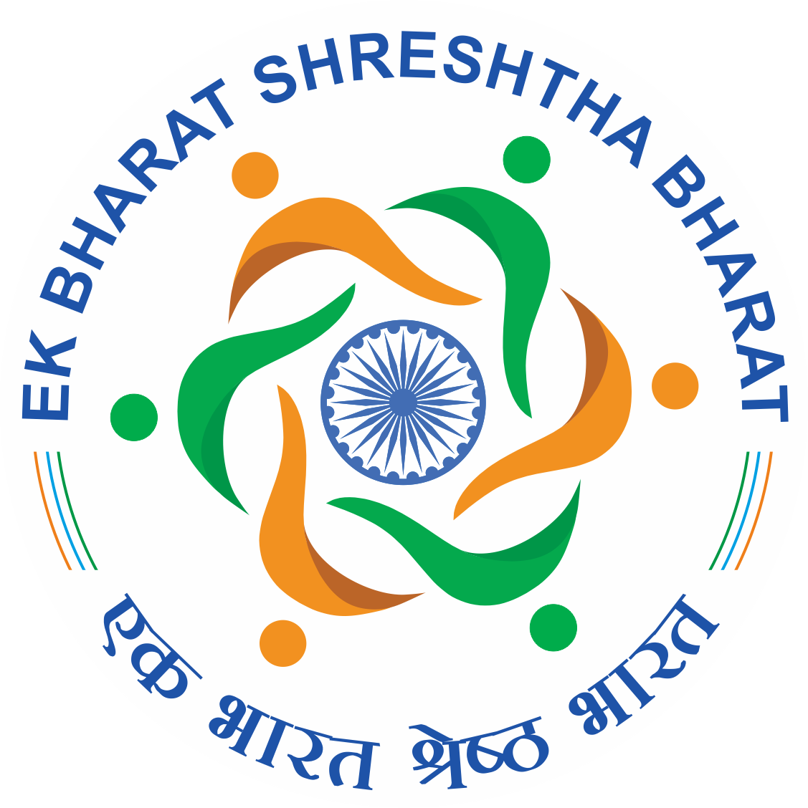 ***Invitation to Student Participants***

*Dear Students*

*Greetings for the day*

*Hope you all are doing well at your end.*

*The last two years were very challenging for all of us and taught us so many things to shape our habit and mind set. All of us put forward our best effort to cope up with the challenges and now our normal days are slowly coming up. On behalf of CITK, we are moving with some vibrant agenda to explore and share your skills and activities to acknowledge your creativity, under “****Ek Bharat Shreshtha Bharat (EBSB)****” Programme, launched on 31 October 2015 on the occasion of the 140th birth anniversary of Sardar Vallabhbhai Patel by the Hon’ble Prime Minister of India, Shri Narendra Modi, which is already uploaded in Govt. Portal of EBSB.*

*Here, we are pleased to inform you that, we are going to have our events “Interaction Programme on Cultural Exchange between the Pairing States” and “Cultural Activities” under “Cultural Exchange” category, on 31st October 2021, at 10.00AM to 11.20AM and 11:30AM to 12:30 PM respectively through online mode. This will be our opening of EBSB Programme under the session 31 October 2021-31October 2022. We decided to have an opening ceremony where the Director CITK, the Registrar CITK and one Invited Eminent Speaker will grace the programme, which will be followed by interactive session and cultural activities. The whole programme will be on online mode and link will be shared with you. In this regard, you are requested to send your small videos on any of Dance, Music, Drama, Literary Festivals, Lecture- Demonstrations, Nukkad Natak from on either Assamese (including all tribes and local people of Assam) or Rajasthani culture.*

*You have to follow the criteria:*

1. *The length of the video should be minimum 3 minutes.*
2. *Performer should be CITK students.*
3. *Any creative work related to either Assam or Rajasthan (one or more)*
4. *Group activity is more preferable.*
5. *Need to send only to email id* [*ebsb@cit.ac.in*](mailto:ebsb@cit.ac.in) *and to Contact Numbers: 7002628336, 6003184018*.
6. *Performance will be selected for the said event after proper review of committee members.*
7. *Performances will be assessed by the committee and the selected students will be notified accordingly.*
8. *The last date of submission of the video for the events to be held on 31st October 2021 is 30th October 2021 (till 12 Noon).*

*The selected activities will be uploaded on EBSB portal and the performers will be appreciated with a certificated of Performance.*

*Thus, we are looking for your active participation and all the students are encouraged to attend the programme and take part in mutual exchange of your thought. It is your programme, so come forward with your own idea and all.*

*All the best.*

**EBSB Committee**

**Central Institute of Technology Kokrajhar, (Deemed to be University, under MoE, Govt. of India)**

**Kokrajhar, B.T.R., Assam, India.**